**Exhibitor Prospectus**

**2025**

**5-6-7 February**

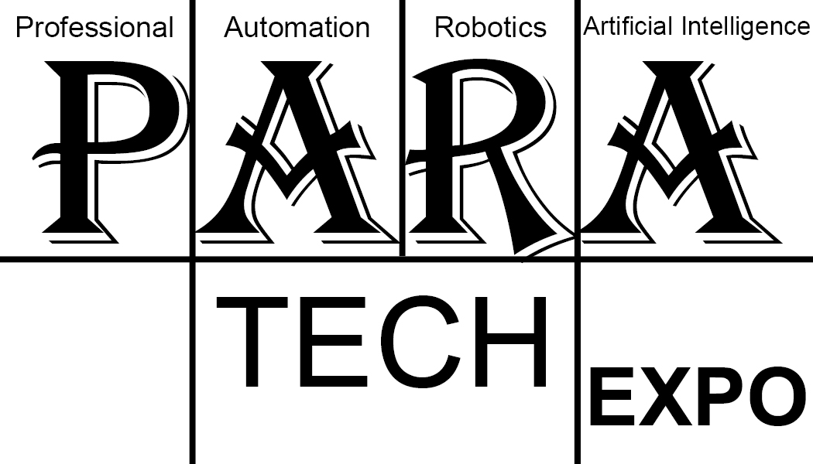

**Sourcing solutions in Industrial Automation**

Venue: CIDCO Exhibition & Convention Centre (CECC), Vashi, Navi Mumbai-400703

**Automation Growth Story**

Automation growth in Manufacturing, packaging, ware­housing is 17-20%. 5G connectivity, IIOT is spurring adoption of automation. Information on cost-effective solutions as well as future-proof solution is imperative.

Imprint Automation India magazine is a valid response to an urgent need of Indian manufacturing industry to source and connect with the right company for the correct solution.

The India Industrial Automation Market size is expected to grow from USD 13.23 billion in 2023 to USD 25.76 billion by 2028, at a CAGR of 14.26% during the forecast period (2023-2028).

The India Warehouse Automation Market size is expected to grow from USD 267.07 million in 2023 to USD 880.98 million by 2028, at a CAGR of 26.96% during the forecast period (2023-2028).

The packaging automation market is currently valued at US$ 74.53 Bn in 2023. By 2033, demand for Packaging Automa­tion is expected to reach a high of US$ 161.66 Bn, the report adds.

The Pharmaceutical Automation Market is projected to reach $18.2 billion by 2029 at a CAGR of 12% from 2022 to 2029. The growth of this market is attributed to the increas­ing adoption of robots in pharmaceutical manufac­turing, government initia­tives to promote industrial development, rising investments in transforming conventional production facilities, and growing demand for safe and digi­tized production processes. The growing demand for IoT in pharmaceutical manufacturing is expected to offer significant opportunities for the growth of this market.

**Highlights at PARA Tech Expo 2025**

1. Exclusive exhibitors only engagement with global pundits of automation.

This session will give guidance on impact of latest technology in automation.

Where lies the future return on investment. The impact of 5G on remote automation. Artificial intelligence and its impact on machine, IIOT (4.0) and digital transformation.

2. CEO conclave white paper on

March of Automation in manufacturing in India – strategy for government and private industry.

Features

1. Pharmaceutical Automation.

2. Packaging Automation.

3. Warehouse Automation.

**Benefits of Attending PARA Tech Expo**

* **Information:** Latest innovation to assist your solution.
* **Strategy:** Discover strategy to integrate automation in your manufacturing. PARA Tech Expo first mantra >> Industrial automation leads to excellence <<
* **Talent:** Meet professionals with expertise join your company. Imprint alert 1 >> Grave storage of engineers and lack of talent <<
* **Future security:** Adopt future proof automation solutions secure ROI on investment in automation.
* **Analyse:** Understand your product automated manufacturing vis-a-vis competitive solution and process select the most appropriate automation.
* **Knowledge:** Benefit from your presence to attend meaningful conference sessions and seminars.
* **Opportunity:** Professionals and companies attend Industries specific association concourse for your product and automation solutions or service.

**Stall Rates**

|  |  |
| --- | --- |
| Area | Table| Chairs| Spotlights| Plugpoints| Dustbin |
| 9 sq.m | As required |
| 12 sq.m | As required |
| 15 sq.m | As required |
| 18 sq.m | As required |
| 21 sq.m | As required |
| 24 sq.m | As required |
| 27 sq.m | As required |

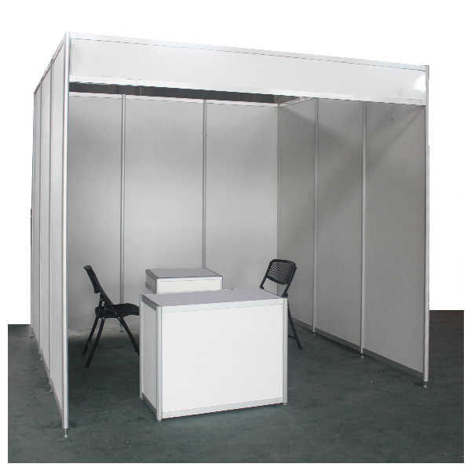

Industry sectors make boxes like website

Next page

Overview of para tech expo from website

Next page

MIDC letter of support